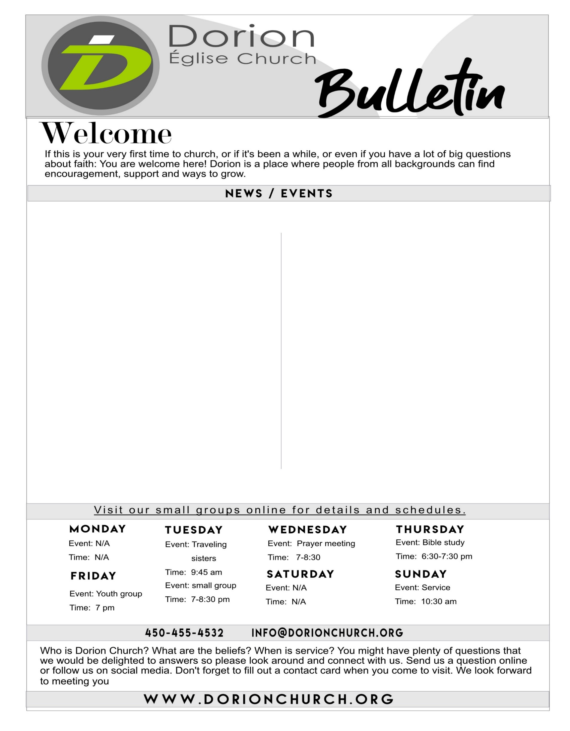

**January 2020**

EVENTS

**Week long Prayers:** Monday January 6th to Saturday 11th we are holding prayer every day from 7pm to 8pm.

**Children’s Ministry:** A new beginning with **the BLUE PRINT** foundation for Jesus classes.Every Friday nightfrom 7-: 8:30pm upstairs.

**Children’s Ministry:** Every Friday we hold Bible study meetings at 7pm at Dorion Church, we invite all to come.Please contact Allan at: [allanmaginoo03@gmail.com](mailto:allanmaginoo03@gmail.com)

**Young Adults Ministry:** Every Friday the young adults hold a Bible study at 7pm at Dorion Church. kadimakd@gmail.com

*Coming up…. Men’s Breakfast Saturday February 15th and special guest Phillip Chasse on February the 16th.*

​

ONLINE

We are always online and you have acces to all info concerning Dorion Church and events. We encourage you to join us on:

***Facebook***, follow whats going on weekly.

***Youtube!*** You can now See and hear our Sermons.

Want to volunteer? Or join a group?

For any information and details on events or if you have questions please visit our website and contact us. [www.dorionchurch.org](http://www.dorionchurch.org)

**Church Work Day:** Reminder that every weekday & Saturday’s at 9AM we encourage all to come and help with manual labor at the church building. This is a great need and your help is greatly appreciated.

**Please contact:** [**info@dorionchurch.org**](mailto:info@dorionchurch.org)

REMINDERS

**Please take note that all group meetings are done on the second floor.**

**Our kid’s area upstairs is ready!** Don’t know where to go?

Make sure to see an Usher to help you and direct you to the correct room.

**Pastor David Charles : 514-914-8588**