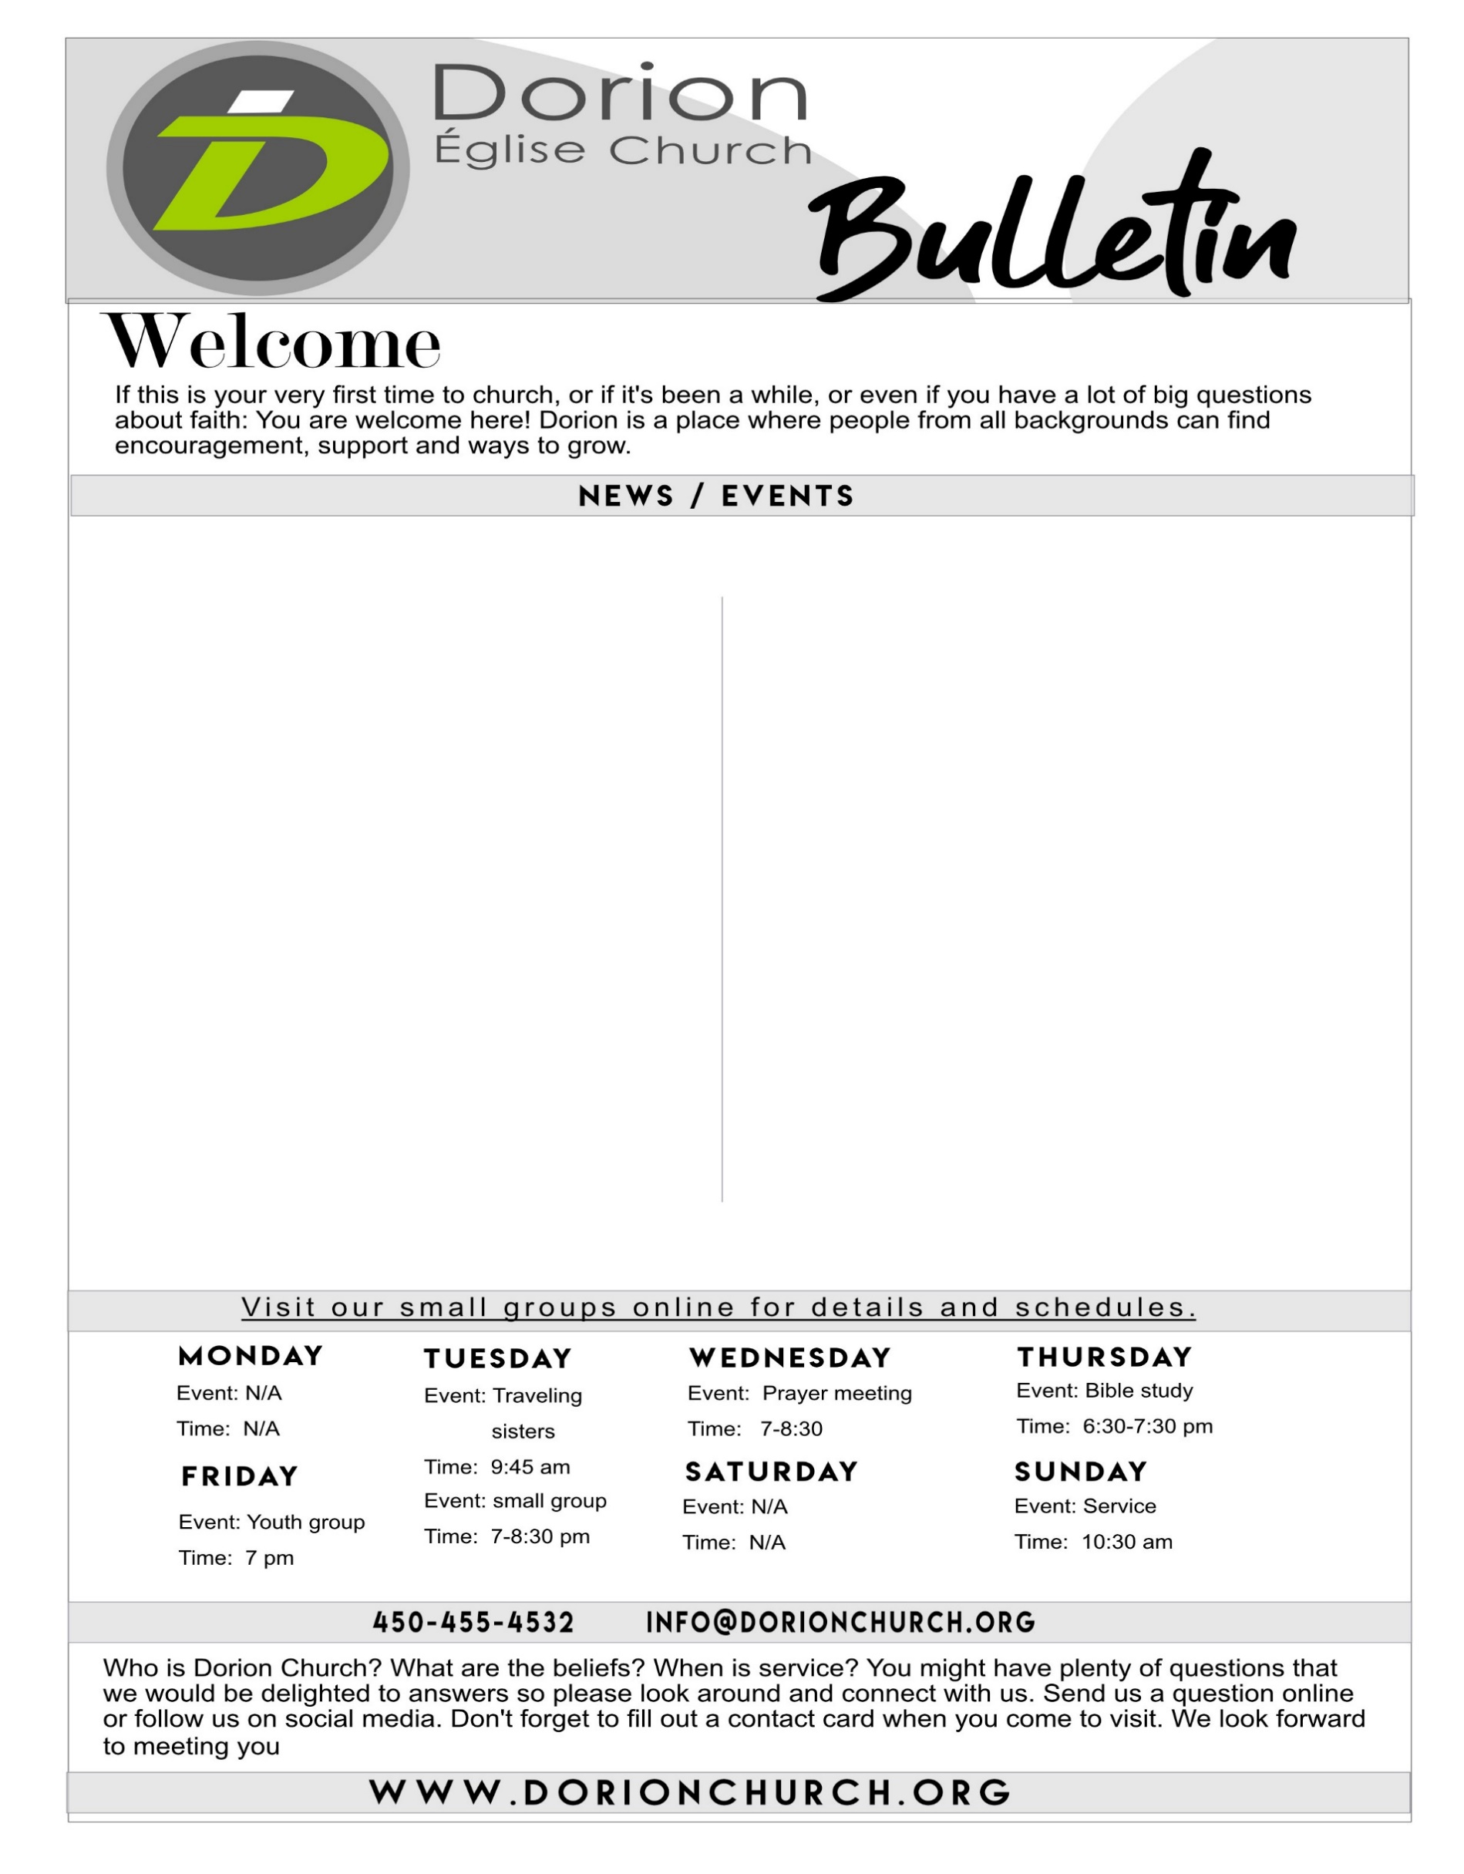

EVENTS

**March 2020**

**Kids Ministry**: Friday March 13th its build a Candy House night. Starting at 7Pm

​**Annual Business Meeting:** Our Annual Business meeting will be held on March29th after service.

​*Coming soon:* ***Marriage conference*** *in April at Dorion Church with Guests Gerry& Kathy Kramer, get your tickets on our website to reserve your spot. 15$ an adult( 18 and over)*

**Men's group** every Wednesday afternoon at 2pm.  Please contact Rolf #  450-455-4944

​**Anthony & Rosalina Group** Tuesday from 7 to 830pm. Theme: Love your Neighbor Please contact Rosalina # 514 623-0725

​

​

**Bible study group** held alternating Thursday’s 6:30pm until 7:30pm, Kids are welcome.Please contact Allan and Ayesah ayesahmasalunga@yahoo.com

**Brian and Gloria Callan** We meet every other Wednesday at our home from 7pm to 8.30pm Contact :Gloria 514-926-0950

​**Traveling Sisters** Meeting every Tuesday's for a breakfast at 9:45 AM Please contact Lise # 514-240-0710

**Facebook**, follow whats going on weekly.

**Youtube!** You can now See and hear our Sermons. Want to volunteer? Or join a group?

For any information and details on events or if you have questions please visit our website and contact us. www.dorionchurch.org

Please contact: info@dorionchurch.org

Please take note that all group meetings are done on the second floor.

Our kid’s area upstairs is still upstairs Don’t know where to go?

Make sure to see an Usher to help you and direct you to the correct room.

**Pastor David Charles : 514-914-8588**